**Contraceptive implant alarm: Safety fear over popular NHS sterilisation device after women who use it are ten times more likely to need an operation later**

* **Essure device permanently sterilises women by blocking fallopian tubes**
* **Around 1,500 women a year are fitted with the device on the NHS**
* **Study in the U.S. has raised concerns that is causes health problems**

By [BEN SPENCER MEDICAL CORRESPONDENT FOR THE DAILY MAIL](http://www.dailymail.co.uk/home/search.html?s=&authornamef=Ben+Spencer+Medical+Correspondent+For+The+Daily+Mail)

**PUBLISHED:** 01:52, 14 October 2015 | **UPDATED:** 05:38, 14 October 2015

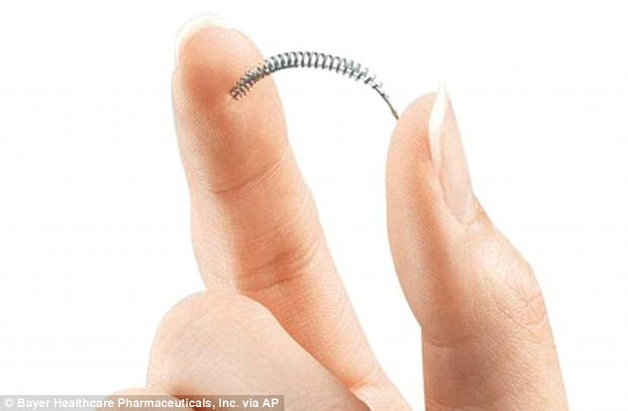

+2

Device: Essure is a titanium coil, pictured, which is inserted into the fallopian tubes and acts as a permanent contraceptive

Safety fears are raised today about a popular and convenient contraceptive implant provided on the NHS to 1,500 women every year.

The Essure device offers permanent sterilisation for those who no longer want to have children and takes only ten minutes to insert without needing surgery or general anaesthetic.

But research published today suggests there is a significant risk the implant can cause health problems.

According to U.S. experts, women given Essure were ten times more likely to need a later operation than if they had undergone surgical sterilisation.

This increased rate of re-operations posed a ‘serious safety concern’, they warned.

Last night British regulators insisted they had no reason to think the device was unsafe but several UK law firms are examining claims on behalf of women who claim to have suffered problems.

In the U.S., the Food and Drug Administration is reviewing Essure after it received thousands of complaints.

Some women claim it has perforated their womb, colon or other tissue.

The device blocks off the fallopian tubes with a tiny piece of titanium, a process called hysteroscopic sterilisation.

Researchers led by experts at Cornell University in New York compared results for 8,048 patients undergoing sterilisation with Essure and 44,278 having standard surgical sterilisation.

The women were treated between 2005 and 2013 in New York State, reported the British Medical Journal.

Those given Essure had to undergo 21 extra re-operations per 1,000 patients compared to those who had the standard treatment.

Tamlin Bolton, from law firm Leigh Day, which is examining claims on behalf of a number of British women in relation to Essure, said: ‘This study is extremely concerning for women with this device.

‘We eagerly await the outcome of the FDA investigation but if Essure is taken off the market in the USA, we would strongly advise the UK Government to rapidly follow suit to prevent hundreds more women being harmed. We are currently investigating a possible group claim.’

Esther Wilkinson, a specialist product liability lawyer at Irwin Mitchell, added: ‘We’ve been contacted by women who have suffered problems after receiving Essure to investigate the problems they have experienced. Although their cases are in the early stages, we are concerned.’

The UK Medical and Healthcare products Regulatory Agency said it was ‘aware of problems some women have experienced’.

A statement added: ‘We have no information to suggest that Essure devices used in the UK are unsafe. If any women experience problems, they should discuss this with their GP.’

Bayer, which makes the devices, said: ‘Over a decade of research and a decade of experience supports the safety and efficacy of Essure.’